**Sábado 5.**

**Continuation will.**

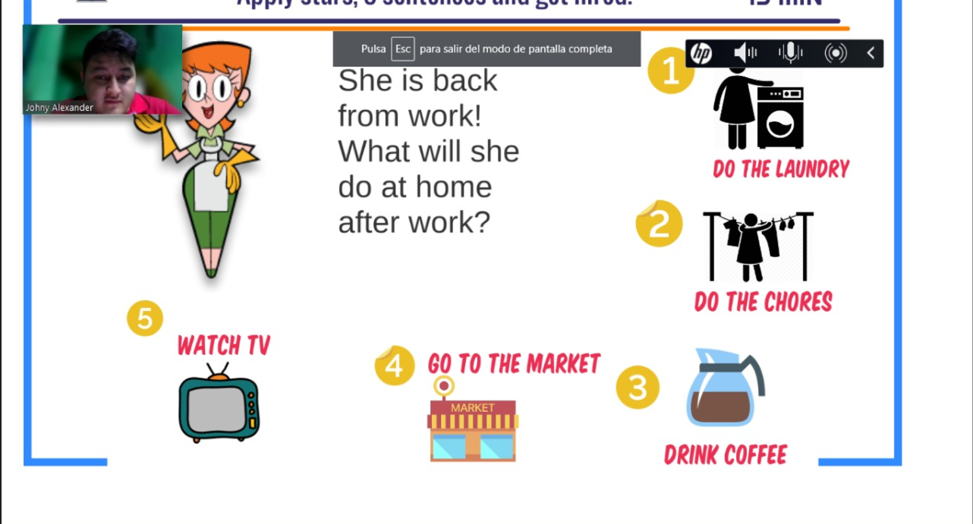

She will clean her room

Next She will do the chores

To continue She will drink a coffee with her friends

Later She is going to go to the supermarket

And finally She is going to watch a videos In these computer.

**Will structure**

**Positive = Subject + Will + Verb(action)**

**Negative = Subject + Will not or Wont + Verb(action)**

**Question = Will + Subject + Verb(action)**

**Examples positive:**

Maria will build a sand castle in the beach

Maria will buy in the supermarket

She will watch a movie

**Examples negative:**

I won’t waste money

I won’t buy shoes

I won’t drink coffee

**Examples questions.**

Will he drive a car?

Will she text to her mom?

Will you run in the park?

What will restaurant visit?

Where will

They get married and

They will travel for 5 years

Then they will have a baby

Later they will visit the beach in California

More later will clean her room because was raining.

After this They will come back them house.

And finally They will have a 2 babies since your travel to California

I will always check my homework but I will never play with my homework.